CMUcam3 Windows Quick Start Guide

- Download and install cygwin
  - http://www.cygwin.com
  - Make sure to install “Make”, “CVS”, “openssh”

- go to http://www.gnuarm.com
  - Go to “Files” and download latest binary GCC tool chain for windows
  - http://www.gnuarm.com/bu-2.15_gcc-4.0.0-c-c++_nl-1.13.0_gi-6.1.exe
  - Install

- Go to http://www.lpc2100.com
  - Download and Install LPC ISP
  - http://www.semiconductors.philips.com/files/products/standard/microcontrollers/utilities/lpc2000_flash_utility.zip

- Open “Makefile” inside CMUcam project
  - Adjust “CFG_LIB” line to point to correct location (base on default path)

- Open up Cygwin Shell
  - Go to CMUcam project
  - Type Make
  - Fix any problems that come up with paths etc

- Connect Camera as shown in figure 1
  - Remember to add “Power Enable Wire”

- Startup in programming mode
  - Hold in push button while turning on power

- Open LPC ISP and load compiled hex file
  - Flash board
  - Close ISP program

- Open up a terminal program
  - Power Cycle Board
  - If the camera is getting power a red LED will turn on
  - If the code is running, a green LED will turn on
  - Make sure it prints a startup message

- Open CMUcam2 GUI
  - See if it detects camera and can send frame
  - GUI does not set serial port correctly, so a terminal program must be run in between downloading from the ISP and use of the CMUcam2 GUI

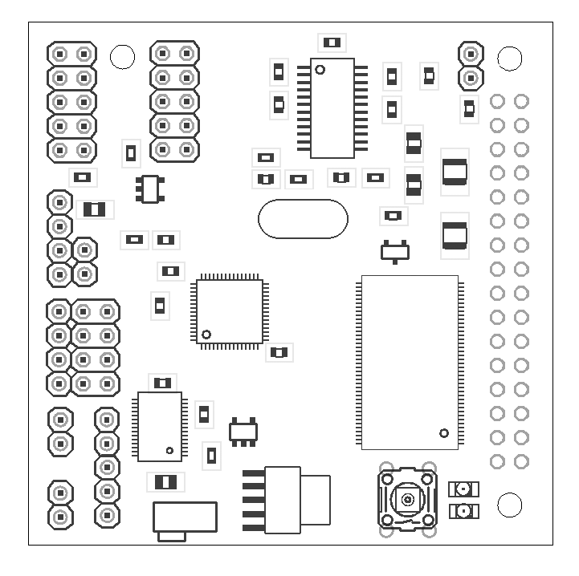
Enable Power
+
-
RS232 Bypass
> 5 volt input select
Serial Port
Enable Power
+
-
RS232 Bypass
> 5 volt input select

Figure 1: Layout of CMUcam3 with required jumpers and connectors indicated in red.

